Definition

Hypertext Transfer Protocol (HTTP) is an application-level **protocol** which is used to access **resources** (eg. hypertext, hypermedia) on the **World Wide Web***(redirect to WWW definition)*through the **Internet**. This protocol is a set of rules that defines the format of data that is being exchanged within or between computers (MDN web docs).

Evolution of HTTP

Sdsa

HTTP was developed by Tim Berners-Lee and his team at CERN in 1989 as part of the 4 building blocks of Mesh or what is now known as the World Wide Web.

HTTP/0.9 - The one-line protocol

The first version HTTP has initially no version number however they versioned it as 0.9 to distinguish it from later versions.

HTTP/0.9 was sometimes referred to as the one-line protocol because the request messages contain only a line of code which is the requests for a specific resource.

GET /mypage.html

For every and the response message contains only the file itself.<HTML>  
A very simple HTML page  
</HTML>

<https://www.w3.org/Protocols/HTTP/AsImplemented.html>

HTTP/1.0 - Building Extensibility

In HTTP 1.0 Host headers are not required, HTTP 1.0 requires a new connection for every request/response on the same connection. Caching in HTTP 1.0 is caught under the header If-Modified-Since. Does not support chunked responses. Supports the methods GET, HEAD and POST.

HTTP/1.1 - The standardized protocol

In HTTP 1.1 Host headers are now required and persistent connections are now supported which means that there is no need to open a new connection for every request/response on the same HTTP connection. The connection nature in HTTP 1.1 is now long lived unlike from the previous versions which terminates the connection after the response.

HTTP 1.1 introduces the new method OPTIONS which describes the communication options for the requested resource. HTTP 1.1 added new headers like Cache-control, Connection, Warning and others. HTTP 1.1 also introduced new 24 status codes.

HTTP/2 – A protocol for greater performance

<https://tools.ietf.org/html/rfc7540>

Resources used for above

<https://medium.com/platform-engineer/evolution-of-http-69cfe6531ba0>

http://www8.org/w8-papers/5c-protocols/key/key.html

HTTP OVERVIEW

HTTP is a protocol which

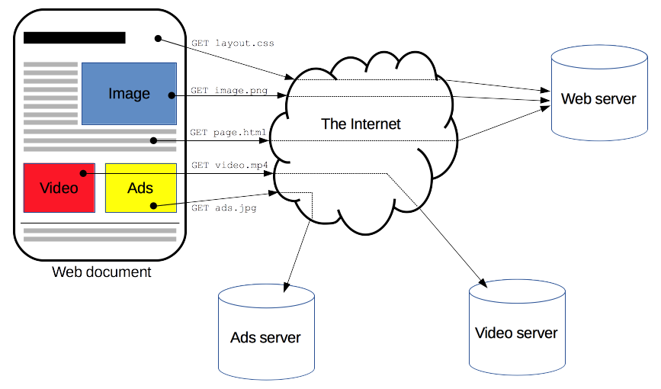

(MDN web docs)

BASIC ASPECTS OF HTTP

* Simple - http was designed to be simple and readable by humans the developments of from http 0.9 upto the http/2 version., has not ffecte the readbility of the
* Extensible-
* Stateless but not sessionless
* Connections

HTTP is a client-server protocol. Requests are sent by the client which is usually a Web browser, to the server which provides a response.Clients or user-agents is not necessarily a web browser, it could also be a robot.

* Origin server - this is the actual machine where the resource resides
* Proxy servers - this are servers that serve the request of a client on behalf of the origin server which is in the case of cache.

HTTP is a pull protocol. The pull of resources by the user-agent will not happen unless the user-agent sends a request

HTTP serves and forgets. After serving the requests sent by user-agents, the Web server forgets the request and serve another request from another user-agent or the same user-agent.

Components of HTTP-based systems

HTTP persistent connection. The early version of HTTP was developed such that when a user-agent request something, the server serves the request then terminates the connection immediately. If earlier version of http which does not allow persistent connection were used today, then resources that are requested would not be loaded properly especially if the resource being requested is dependent from another resource. Persistent connection allo several resources to be fetched with the same connection.

HTTP multiplexing and pipelining (HTTP 2). HTTP multiplexing and pipelining

// draw

HTTP-based systems are made of 3 components, the client/user-agent, the Web server, and Proxies.

Client: the user-agent